**Part 1**

**Code**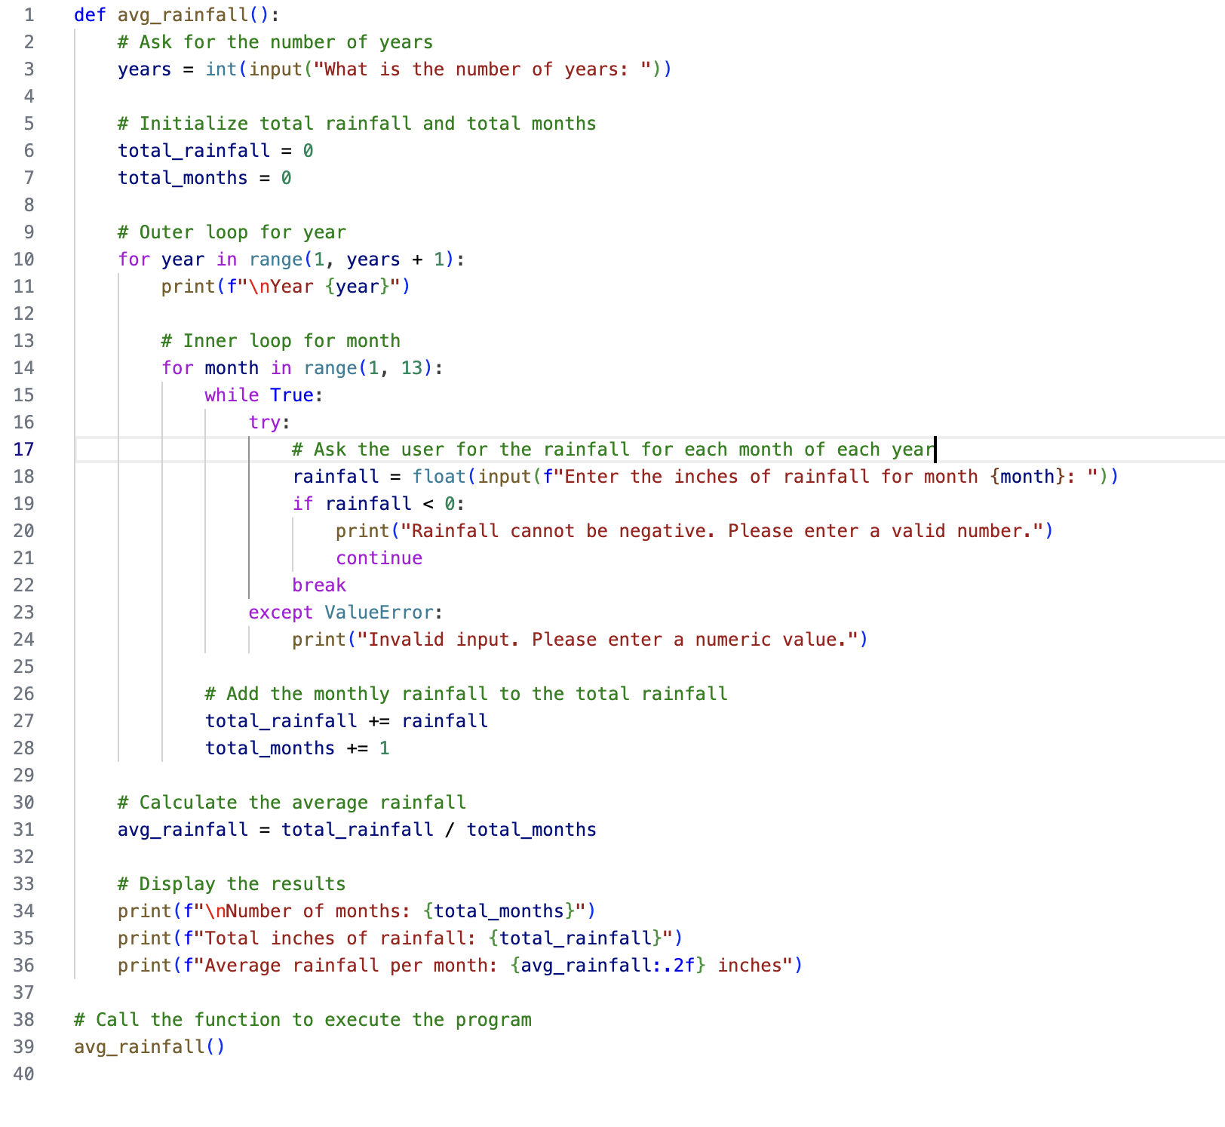

**Code Execution**

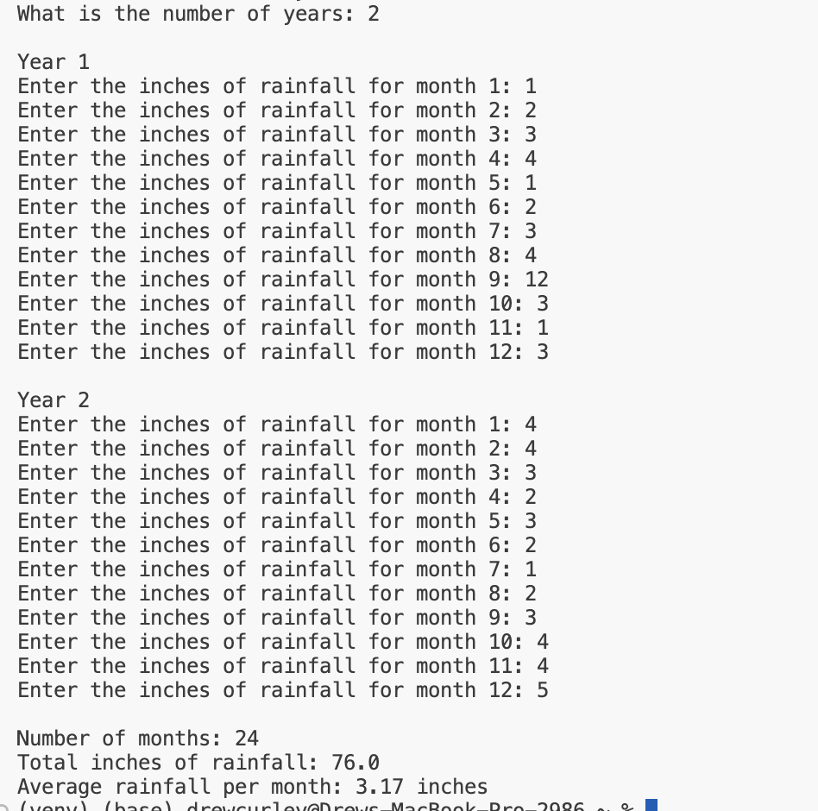

**Part 2**

For this problem, I noticed a quirk in the write up:

* If a customer purchases 0 books, they earn 0 points.
* If a customer purchases 2 books, they earn 5 points.
* If a customer purchases 4 books, they earn 15 points.
* If a customer purchases 6 books, they earn 30 points.
* If a customer purchases 8 or more books, they earn 60 points.

What happens if the customer purchases 1, 3, 5, or 7 books? Do they not earn any points? I decided that the most likely situation was that they would only get the points for the lower amount. So, for 1 book, no points were awarded. For 3, 5 points were awarded just like for 2 books. For 5 books, they received the same number of points as those buying 4 books. For 7, they received the same number of points as those who purchased 6 books.

**Code**

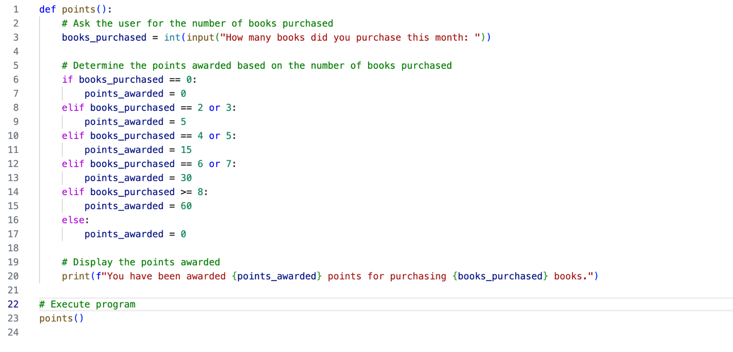

**Code Execution**

